**Prerequisite:**

* 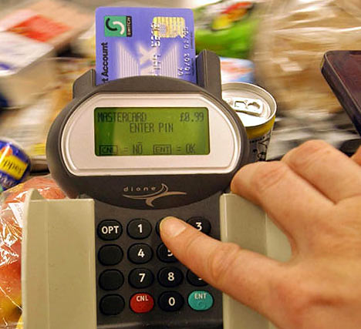Completed Programming Assignment #1
* Program to identify 4 digit PINs (Personal Identification Numbers)

**Assignment:**

1. Extend your PIN Program to validate 6 digit PINs
   * The result should be to tell the user if the PIN is a good PIN   
     or if the PIN is an easy PIN to guess.
2. Read in the 6 digit user PIN as a string or a list (your choice)
   * i.e. use pinNumber = str(input(“Enter a PIN”))
3. Check that the PIN is valid
   * Check that there are no letters
   * Check that there are no spaces or punctuation marks
   * Leading zeroes are valid and significant (e.g. “000001” is a valid PIN)
4. Check for the use of simple patterns (e.g. “111111”)
5. Check for the use other common patterns (e.g. birthdays, etc.)
6. Print out a PIN analysis summary
   * That the PIN is valid or invalid
   * If the PIN is easy or hard to guess

import time

startTime = time.time()

loopCount = 1

stringLetters = str(input("Please enter the string of number: "))

pin = ("".join(stringLetters))

pin = int(pin)

if (pin == 111111):

print ('\u001b[36m'"Your pin is 111111")

print ("This was easy to guess!")

elif (pin == 100000) :

print ('\u001b[36m'"Your pin is 100000")

print ("This was easy to guess!")

elif (pin == 123456) :

print ('\u001b[36m' "Your pin is 123456")

print ("This was easy to guess!")

elif (pin == 102004) :

print ('\u001b[36m'"Your pin is 102004")

print ("This was easy to guess!")

elif (pin == 999999) :

print ('\u001b[36m'"Your pin is 999999")

print ("This was easy to guess!")

elif (pin == 666666) :

print ('\u001b[36m'"Your pin is 666666")

print ("This was easy to guess!")

elif (pin == 000000) :

print ('\u001b[36m'"Your pin is 000000")

print ("This was easy to guess!")

elif (pin == 121212) :

print ('\u001b[36m'"Your pin is 121212")

print ("This was easy to guess!")

else :

print ("Your pasword is secure")

count = 1

while (True) :

count = count + 1

print ('\u001b[36m'"Get ready", count + 1)

if (count >= pin) :

break

else :

count = count + 1

endTime = time.time ()

print('\u001b[31m'"Elapsed time is:", (endTime - startTime))